1. Start page of task 2

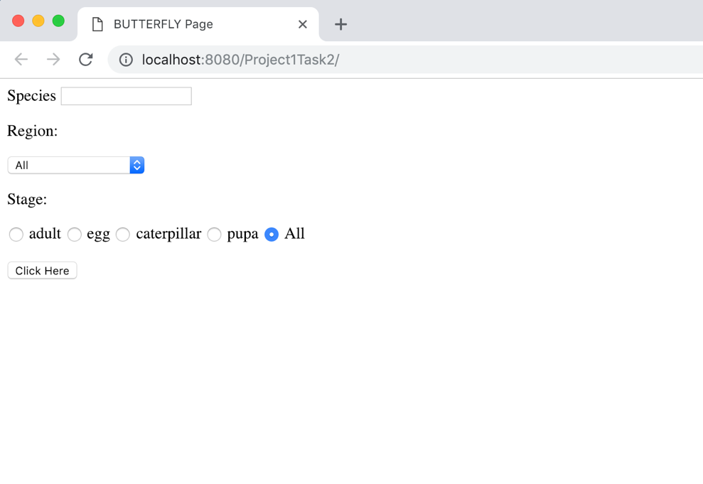

1. Search random picture when species = all, region = all and stage = all, it will randomly get a picture from 48 pictures.

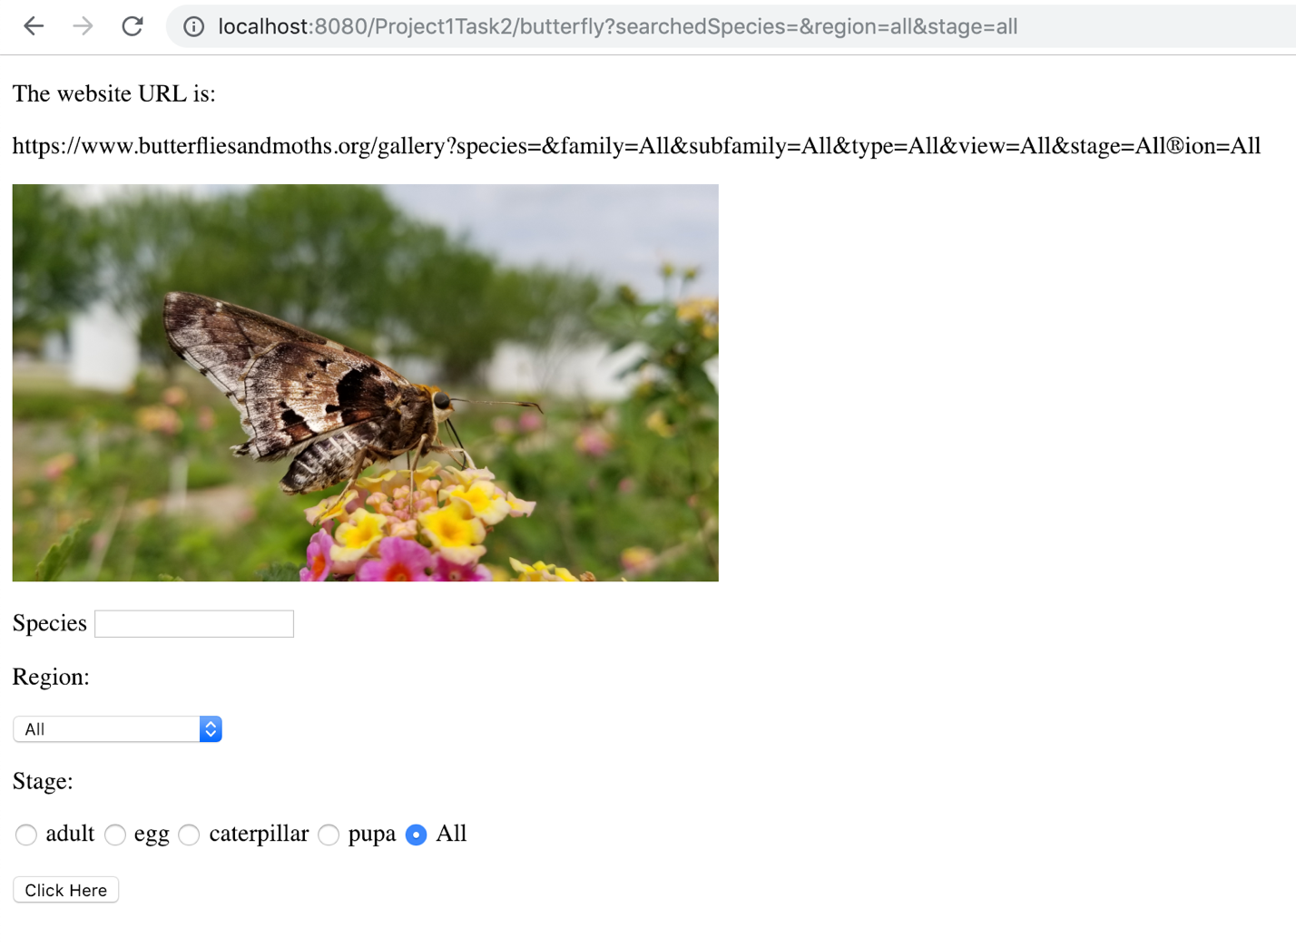

1. Search random picture when species = Astraptes alector and others as “all”

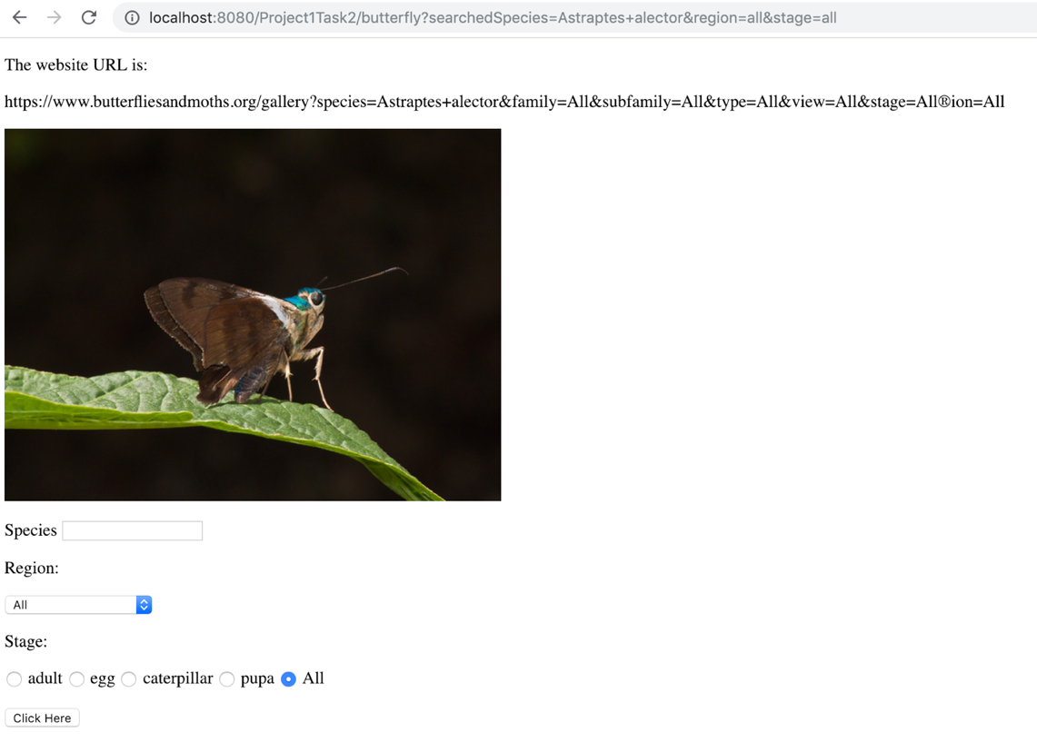

1. Search randomly when region = Panama, and others = all, it will get different results each time, this is the random picture for the first time

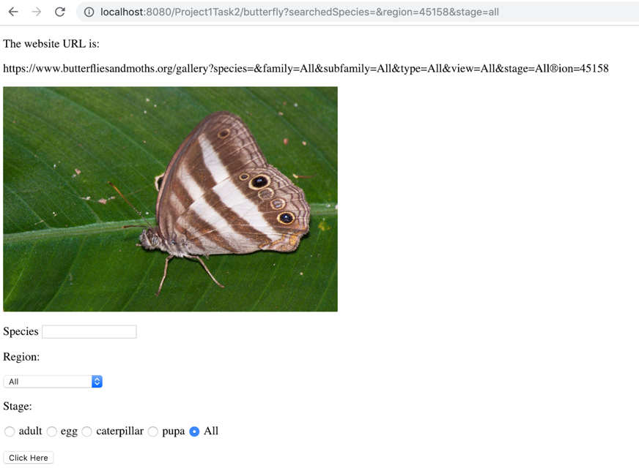

Search randomly when region = Panama, and others = all, it will get different results each time, this is the random picture for the second time

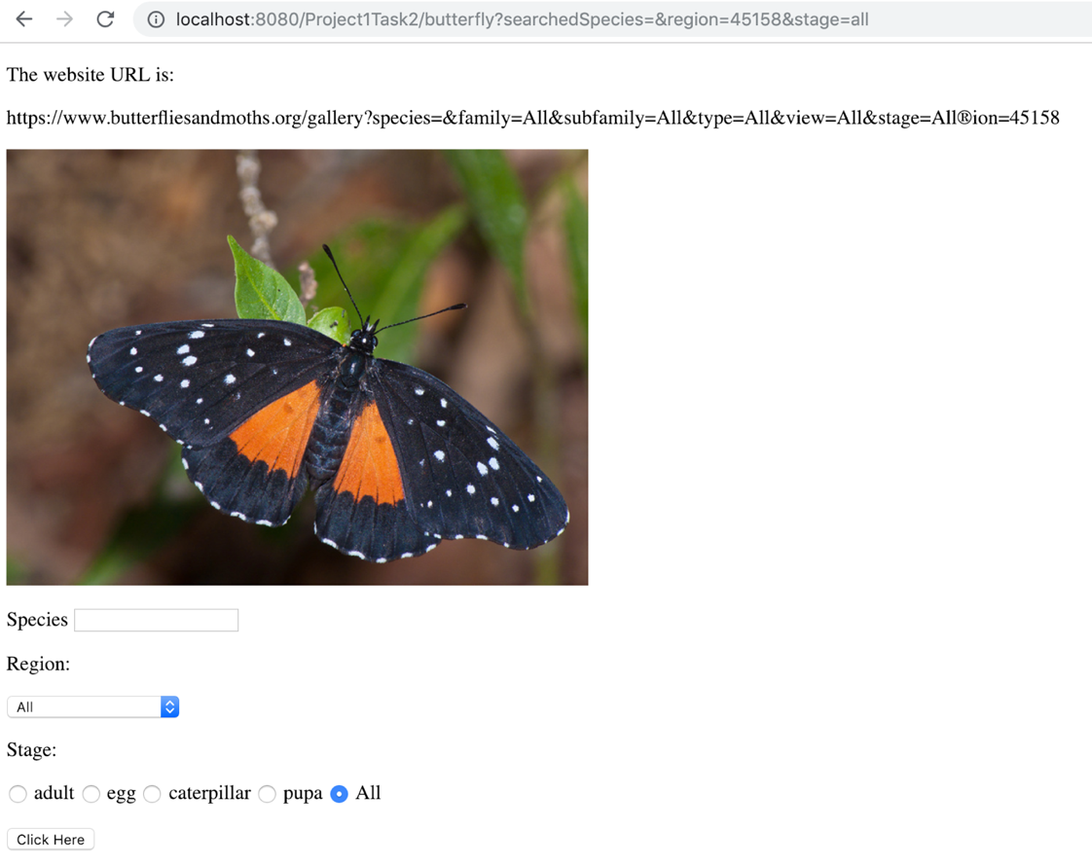

1. Search when the species = Mertzmoth and there is no result

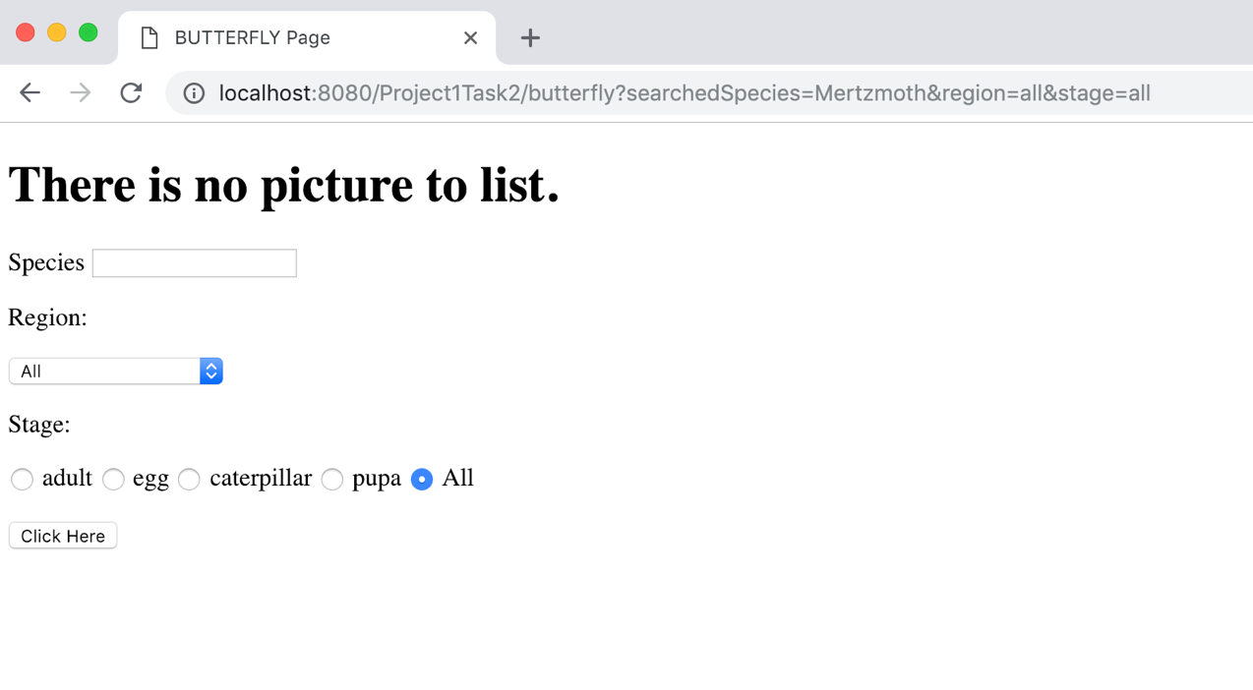

1. Search when there is no wifi, it will show that there is no picture to list

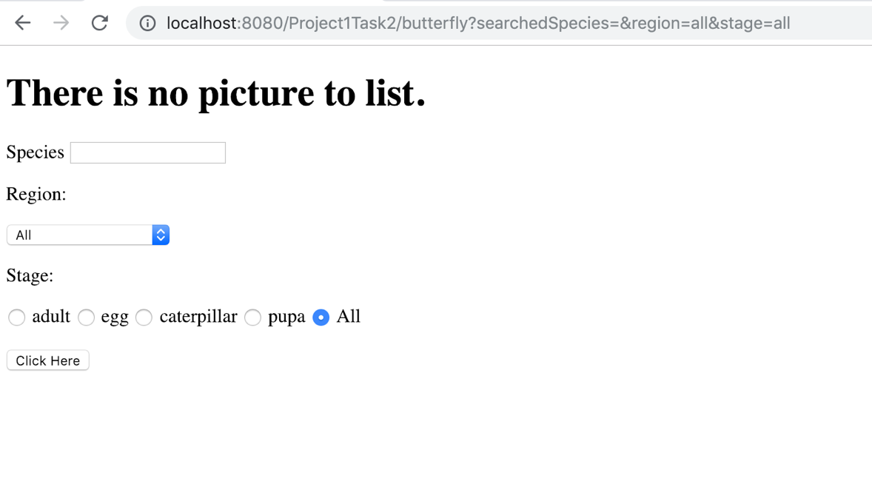

1. In mobile mode, the picture will get adjusted with the width of the screen

 